# Creating a Continuous Quest with ScriptEase II

The goal of this tutorial is to create a continuous quest. We added and succeeded Story Points in the last tutorial. This time, we will find out how to go back to a previously succeeded Story Point to make a repeatable quest.

This tutorial will explain why this can be useful by implementing a lever puzzle. Once you have completed this tutorial, you will have an even better understanding of the story system and how it can be used not just for story management, but also for game mechanics.

## Getting Started:

1. Back up your *.ses file and module as usual. It’s good to get into the habit of this now, before you work on a large scale project where you could lose weeks of work.
2. Make sure ScriptEase II is closed then start up the Aurora Toolset.

## Adding Levers:

1. We need to add some levers to our cave in order to start the puzzle. Open the Cave area. Edit Copy one of the floor levers found in “Placeables” 🡪 “Standard” 🡪 “Containers & Switches”. Name it “Lever 1” with the tag “lever1”.  
   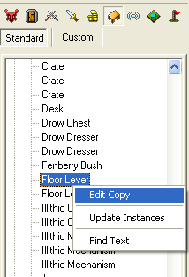
2. Create two copies from this lever using Edit Copy and name them “Lever 2” and “Lever 3”, with tags “lever2” and “lever3”.
3. Add the three levers in a row in front of the locked door in the Cave, on the side of the entrance. The player will be pulling these in a specific order to open the door.

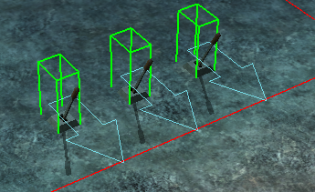

1. Right click each of the placed levers and set their “Initial State” to “Deactivated”.

## Scripting a Lever:

1. Save and close Aurora, and then open your story in ScriptEase II.
2. Add a new Story Point to the Story Graph after the “Rum Retrieved” Story Point from the last tutorial. Name it “Lever Puzzle”.
3. This Story Point is only going to be used to provide a reference for our Journal Record. Therefore, we can succeed it as soon as it becomes active.
4. Select the Lever Puzzle Story Point. We need to add a “When story point is activated” cause to the Story Point. Set the Story Point slot to Lever Puzzle.
5. Add a Journal Record for this Story Point to the “Current Active” Yes section by using the appropriate effect. Set the Story Point slot to Lever Puzzle.
6. Drag a “Succeed Story Point” effect into the Yes section and then drag the Lever Puzzle object into the effect’s Story Point slot (Figure 1).

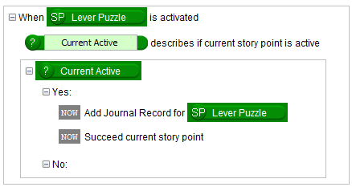

Figure

1. Now create another Story Point after Lever Puzzle and name it “Lever 1 Activated”.
2. Select the new Story Point. Add a “When subject is used by Last User” cause into the Story Point and drag the “Lever 1” object into the subject slot. “Lever 1” should be found in the Placeable category at the lower left object pane.
3. Our lever puzzle will be very simple; the order will be pulling Lever 1 🡪 Lever 2 🡪 Lever 3. Add a Succeed Story Point effect to the Yes section of the cause.
4. Let’s also animate the lever. Drag in an “Animate Placeable to Open” effect above “Succeed current story point”. There are a few animation effects, so make sure you use the placeable one. Drag the Lever 1 object into the Placeable slot, and set the animation to “Activate”.
5. We also need to give the player some information in their Journal. Add a Journal Point to the **Lever Puzzle** journal record that shows the text, “Pulling the first lever seems to have worked. I should pull another one.” (Figure 2).

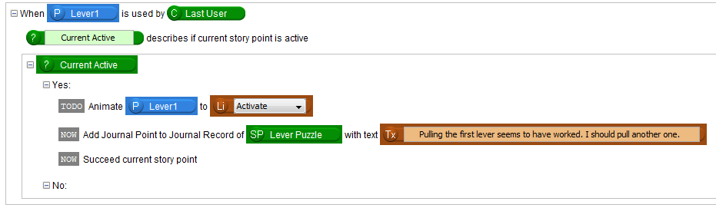Figure

## Resetting the Levers:

1. We need some behaviour in case the levers are pulled out of order. So, if we pulled the second lever before this one, all of the other levers should reset and we should come back to this point in the story.
2. We will use the No section for this. Add three “Animate Placeable to Open” effects to the No section. Drag in the three different lever game objects, and set all of the animations to “Deactivate.”
3. We should then restart the quest at Lever 1. We do this by using a “Continue story at Story Point” effect with Lever 1 Activated in the Story Point slot. This will restart the story back at this story point.
4. Lastly, add a Journal Point to the **Lever Puzzle** Journal Record with the information “That didn’t work. The levers reset. “ (Figure 3)

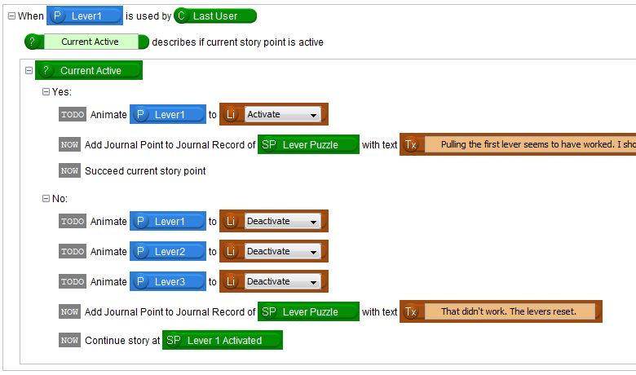

Figure

Looking at Figure 3, we have set up the first of the three levers. If the player is at this point in the story, it means the player is facing the lever puzzle and ready to pull one of the levers. If the player pulls Lever 1 (the correct lever), we go in the “Yes” section, Lever 1 activates, and this Story Point succeeds. If instead, the player pulls another lever, then we go in the “No” section, all levers deactivate, and the story resets itself to the beginning of the puzzle.

## Copying Story Points:

1. Let’s create two more Story Points in succession after Lever 1 Activated. We won’t rename them just yet since we will have to later.
2. These Story Points will be almost exactly the same as Lever 1 Activated. To save ourselves some work, let’s use copy and paste. Click on Lever 1 Activated in the Story Graph and then navigate to the menu item Edit 🡪 Copy, or press Ctrl+C on the keyboard to copy the current Story Point.
3. Click on the next Story Point and then navigate to Edit 🡪 Paste, or press Ctrl+V on the keyboard to paste the copied Story Point into the current selected Story Point. Pasting Story Points pastes their contents, not the Story Point itself.

Tip:Pasting a Story Point pastes its contents. If any bound slots are invalid, they will lose their bindings! Always check pasted components.

Tip:You can also paste Story Points between two open stories. This makes it easy to collaborate on the same story.

1. Do the same for the other New Story Point.
2. The story points we copied were pasted verbatim, so we need to edit them. Start by renaming the new Story Points to “Lever 2 Activated” and “Lever 3 Activated” (Figure 4).



Figure

1. In the Lever 2 Activated Story Point, change the slot of the cause from Lever 1 to Lever 2.
2. Animate Lever 2 in the Story Point “Current Active” Yes section instead of Lever 1.
3. Succeed Lever 2 Activated instead of Lever 1 Activated.
4. Change the text of the created Journal Point to make more sense. The Story Point “Current Active” No section stays the same. When the wrong lever is pulled, the story should always reset and continue from the “Lever 1 Activated” Story Point, don’t change that. The Yes section will be slightly different (Figure 5).

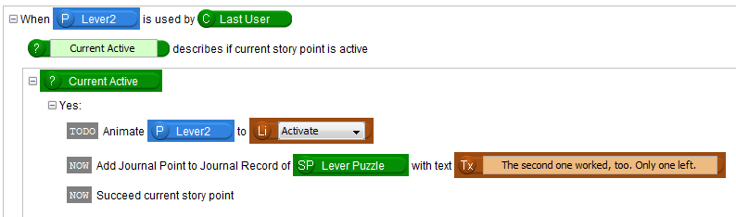Figure

1. Rename and change the appropriate slots in the “Lever 3 Activated” Story Point as well (Figure 6).

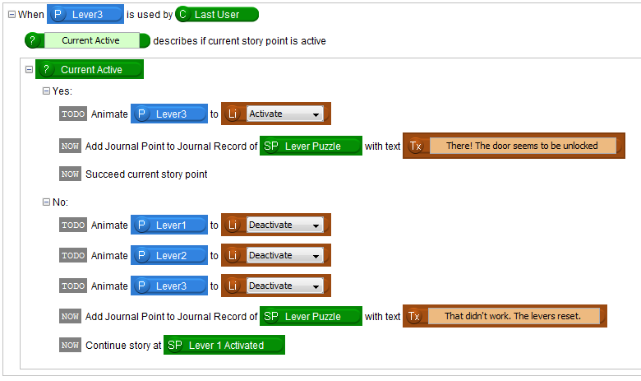Figure 6

## Finishing the Story:

1. We also want to unlock the door when the lever puzzle is completed, or else the puzzle won’t have any point to it. Add a “Set the Object to Unlocked” effect to “Lever 3 Activated” Story Point Yes section and drag the Treasure Room Door into the Object slot.
2. Let’s destroy all of the levers using three “Destroy Target” effects so that we can’t use them again.
3. We can finish the Lever Puzzle Journal Record at this point by using a “Finish Journal Record of Story Point” effect. Drag the “Lever Puzzle” story point into the effect’s slot. Finishing a Journal Record closes the journal record and no more Journal Points can be added to it. Here it basically means that the player has completed the lever puzzle.
4. We should also update the Journal Record of our main storyline now. Add a Journal Point to the Treasure Island Journal Record with some text saying that you finished the puzzle and can continue onto the next part of the story (Figure 7).

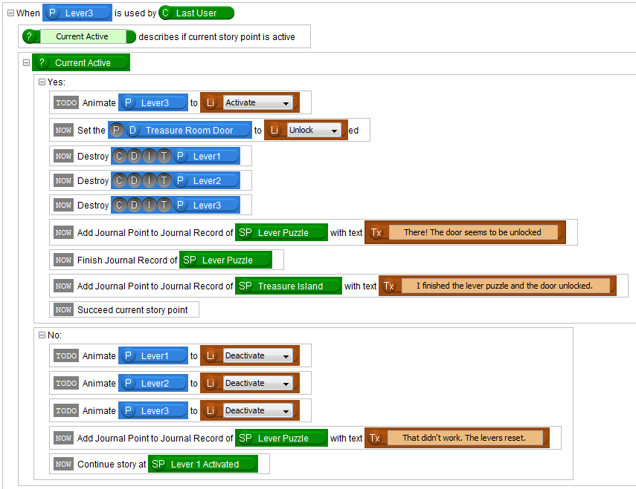Figure 7

1. Save your story and test it out.

You have learned how to use the story system to restart stories at certain points. You could also use this system to create infinitely repeatable quests in your story.

You also learned how to copy and paste Story Points, which you will likely use if you are making a game with other people. ScriptEase II disposes of files in your game created by other ScriptEase II stories, so it’s recommended to always keep one story file per module as your main story file. Copying and pasting lets collaborators work on different parts of the story, and then combine them all into the main story file.

The levers are currently getting destroyed, which isn’t the most elegant solution. You may try to find a different way to do this, or add a visual effect to the destruction to make it less awkward.